EX1

Please create a new folder, lab3, in your home directory. Change the sample provided in the archive, to allow you to count how many times was accessed each file from lab3 folder. Please create another folder in the lab3 folder, let’s call it lab31 and see if your application is counting how many times were accessed each file from lab31 folder. Please explain the obtained results

(To compile inotify.c file you will run this command: gcc -o in inotify.c)
In sha256 folder you will find a small program which will help you to compute sha256 hash for a file. You can compile it using this command:
gcc -o t test.c sha-256.c
In the same folder you will find also another file, called eicar.txt

See the written program for the result

EX2
Please compute the sha256 hash for eicar.txt file. Now enter on the site https://www.virustotal.com/gui/home/upload and select search tab. Please insert the computed sha256 hash and see the result you obtain for that hash. Try similar tests with other files and see the results.
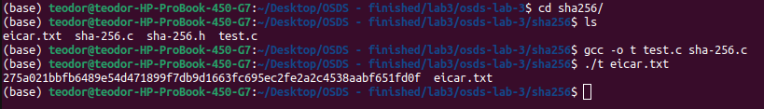
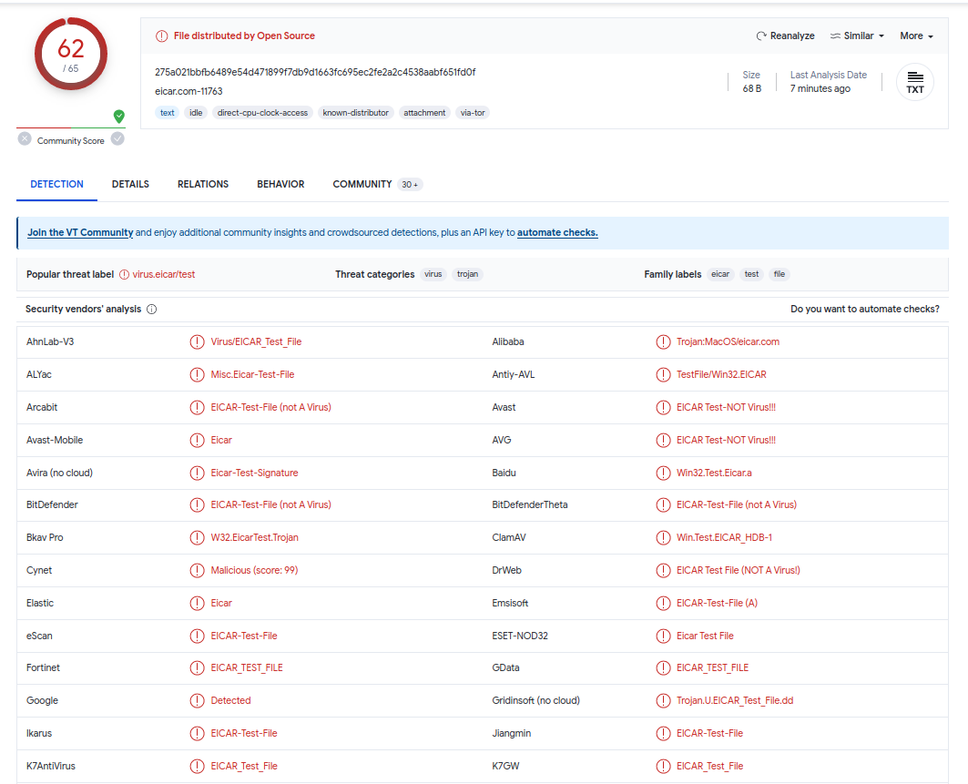

EX3
In folder curl from the archive you will find a sample which uses curl to send a http(s) request to a server and get the server response. Please look at the code. Change the requested url with different other urls you are usually accessing and see if you obtain those pages

Commands:
sudo apt-get install libcurl4-openssl-dev
gcc curl.c -o curl -O2 -Wall -lcurl → O2 (optimised code)
→ Wall (displays detailed warnings)
→ curl (bennds the program to libcurl)
./curl

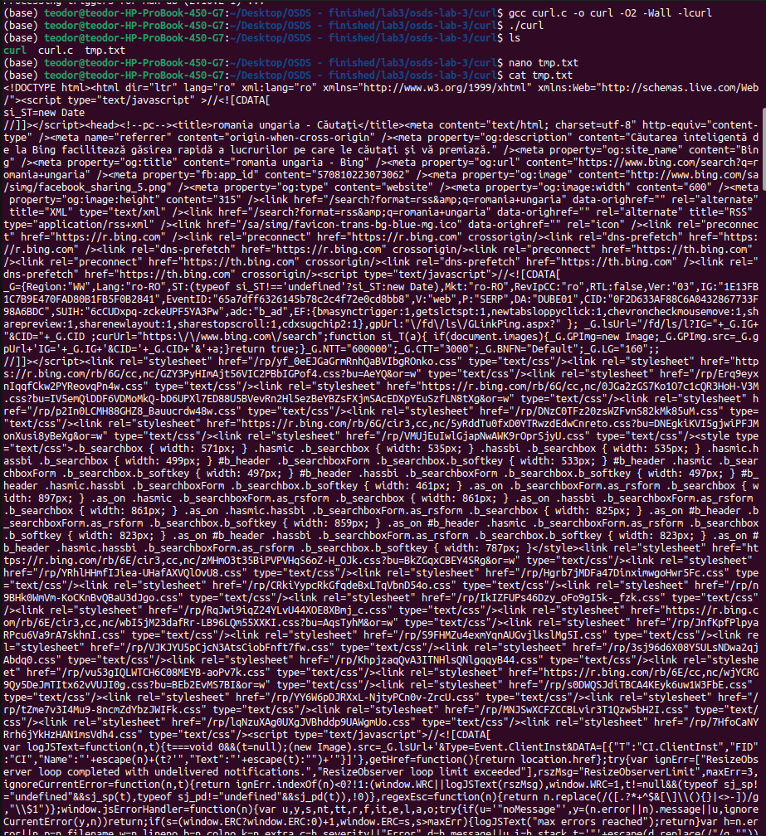
We will get the tmp.txt with the following content (and also we will get similar results for other links)

